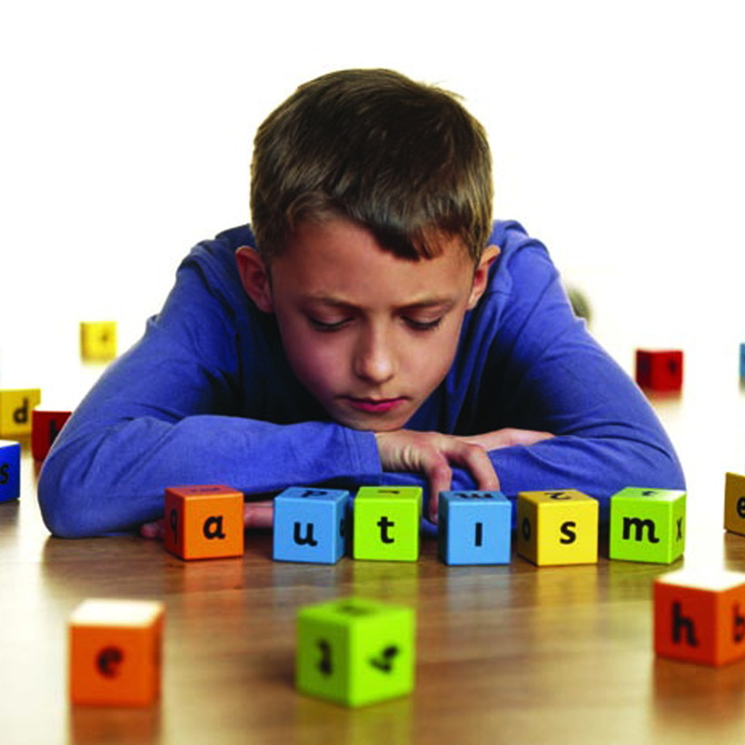

**研究背景和意义：**

**Predicting Autism & Other Developmental Delays: How Tech Can Empower Doctors**

<https://www.laboratoryequipment.com/article/2017/12/predicting-autism-other-developmental-delays-how-tech-can-empower-doctors>

**Quora:**

**Can machine learning diagnose autism?**

<https://www.quora.com/Can-machine-learning-diagnose-autism>

**Data challenge：**

IMPAC - Imaging-psychiatry challenge: predicting autism

<https://paris-saclay-cds.github.io/autism_challenge/>

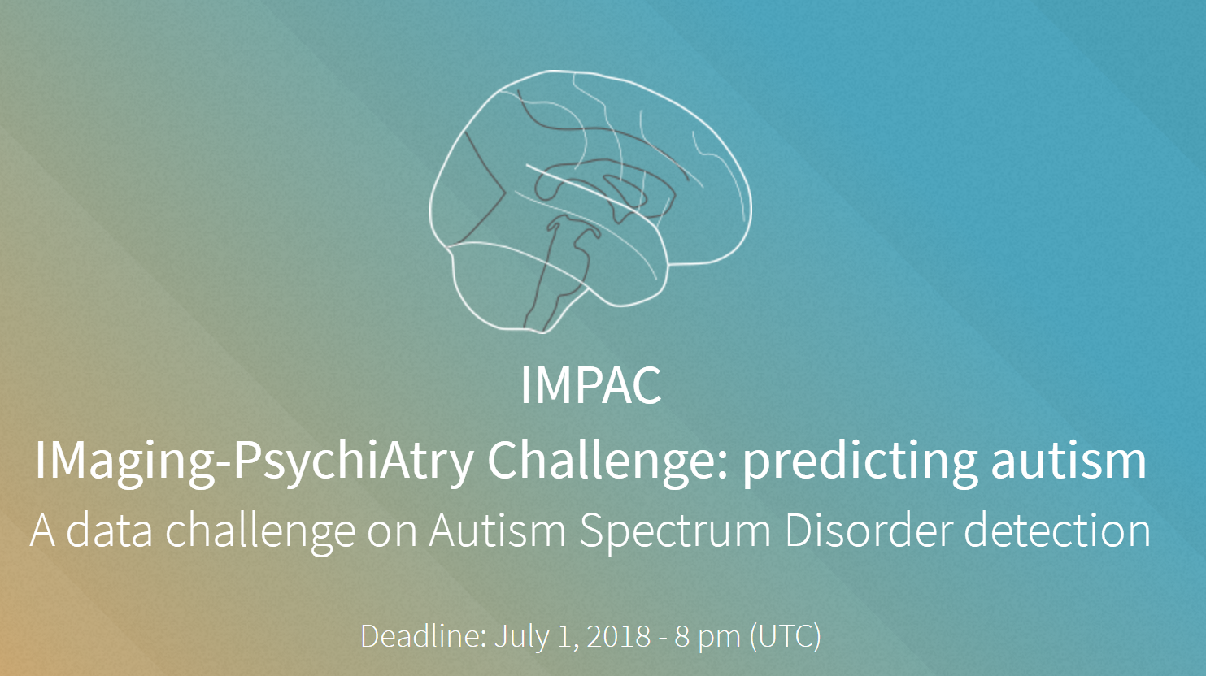

Brain images from more than 2000 individuals

Multimodal imaging data： Structural MRI， Functional MRI

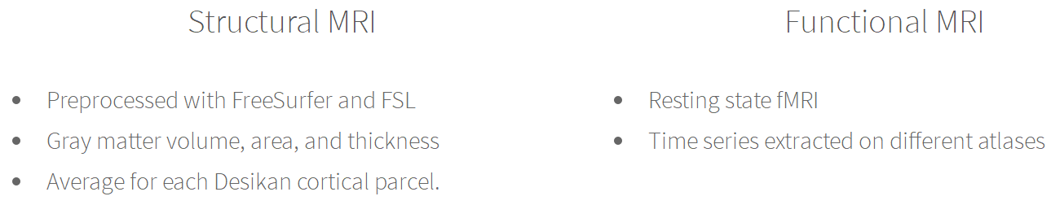

**GitHub：**

munsellb/dl_autism （Not Yet to Run， implemented on MATLAB）

<https://github.com/munsellb/dl_autism>

**Public dataset：**

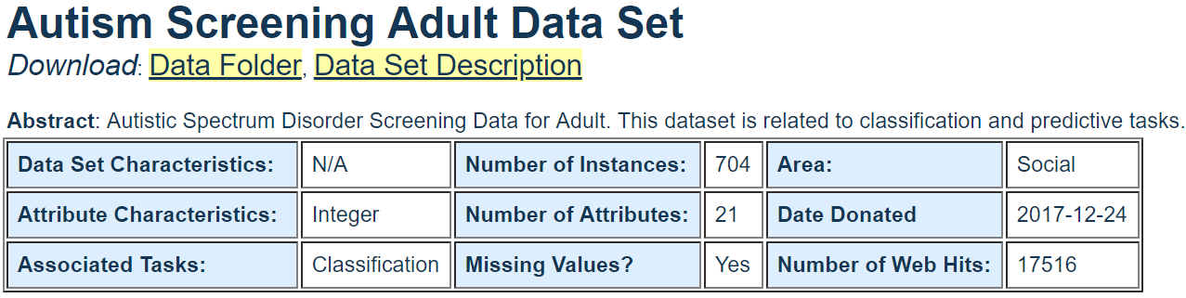

https://archive.ics.uci.edu/ml/datasets/Autism+Screening+Adult

**Leading Research Group：**

The Wall Lab at Stanford School of Medicine

<https://wall-lab.stanford.edu/>

the lab’s presentation：machine learning approaches to disentangle the complexity of autism

<https://www.youtube.com/watch?v=PJsu0dZ-Pr0>

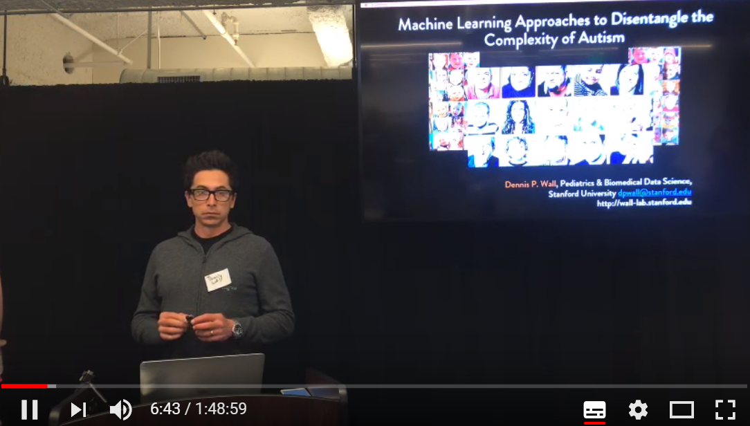

**相关商业报道：**

儿童自闭症AI诊断平台Cognoa首获FDA监管认证_量子位_传送门

<http://chuansong.me/n/2200742353126>

【了解孤独症】人工智能自闭症筛查领域标杆Cognoa，获2000万美元融资，引发有关自闭症APP的思考！_搜狐科技_搜狐网

<http://www.sohu.com/a/152919038_275605>

**Paper List**：

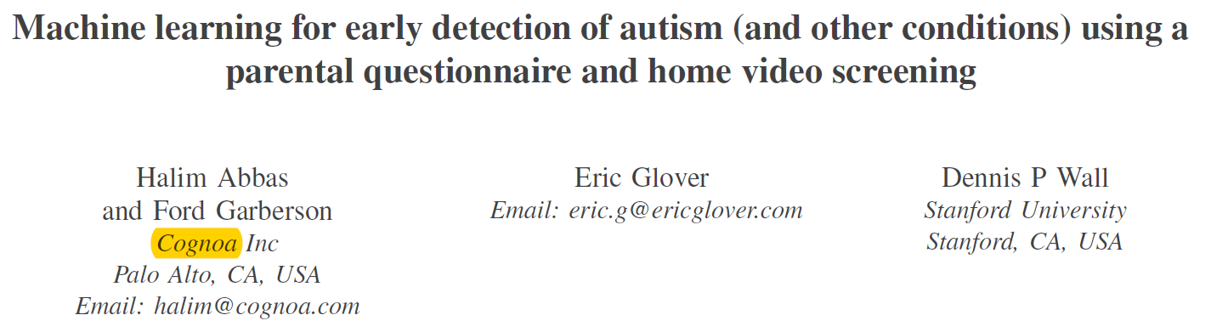

978-1-5386-2715-0/17/$31.00 ©2017 IEEE

介绍得相当简略，都是思路和概念的描述。

具体细节见下面文献。

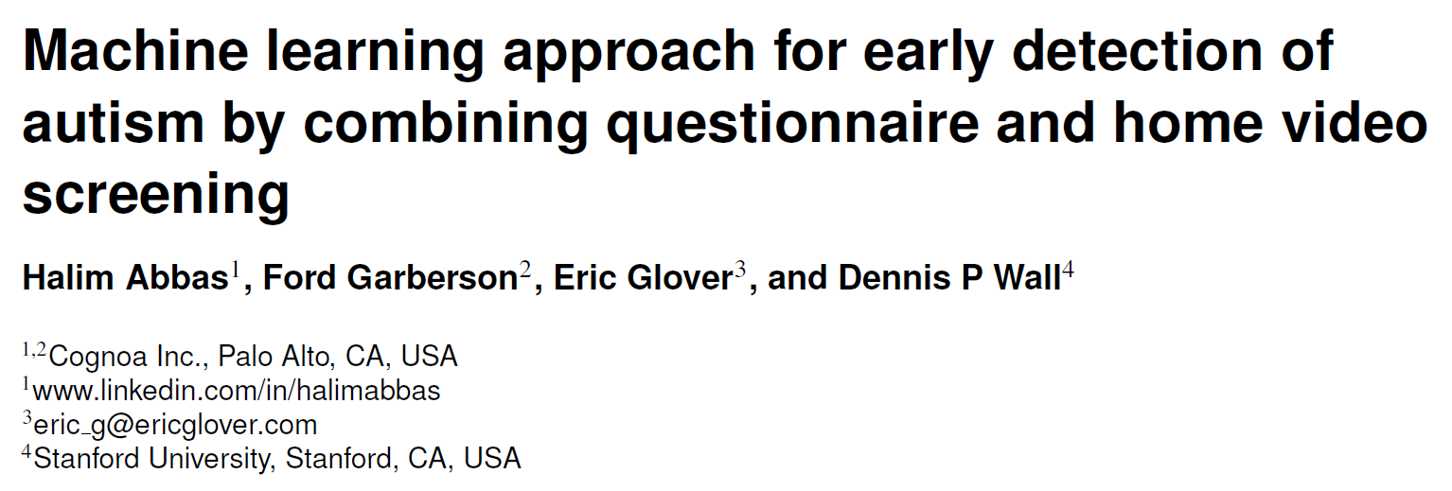

arXiv:1703.06076v1